**World Happiness Report**

**Data Description:**

The World Happiness Report is a publication of the Sustainable Development Solutions Network (SDSN), an initiative launched by the United Nations in 2012. It is an annual report that measures the happiness and well-being of people in countries around the world. The report is based on data from the Gallup World Poll, which surveys people in over 150 countries and asks them to rate their life satisfaction on a scale from 0 to 10. The report continues to gain global recognition as governments, organizations and civil society increasingly use happiness indicators to inform their policy-making decisions. Leading experts across fields – economics, psychology, survey analysis, national statistics, health, public policy and more – describe how measurements of well-being can be used effectively to assess the progress of nations. The reports review the state of happiness in the world today and show how the new science of happiness explains personal and national variations in happiness.

**Covid-19 impacts on Happiness Report:**

The World Happiness Report also highlights the impact of the COVID-19 pandemic on global well-being, with many countries experiencing a decline in happiness levels due to the pandemic's social and economic consequences. The report provides important insights into the factors that contribute to happiness and well-being and can be used to guide policies and initiatives aimed at improving the lives of people around the world.

**Six indicators for Happiness Score:**

The columns following the happiness score estimate the extent to which each of six factors – economic and social support, life expectancy, freedom to make life choices, absence of corruption, and generosity – contribute to making life evaluations higher in each country than they are in Dystopia, a hypothetical country that has values equal to the world’s lowest national averages for each of the six factors which explain why some countries rank higher than others. The report also aims to provide policymakers and researchers with insights into how to improve people's well-being and happiness.

**Contents:**

The happiness scores and rankings use data from the Gallup World Poll. The scores are based on answers to the main life evaluation question asked in the poll. This question, known as the Cantril ladder, asks respondents to think of a ladder with the best possible life for them being a 10 and the worst possible life being a 0 and to rate their own current lives on that scale. Data has been downloaded from Kaggle, It includes 2020 and 2021 years data. We will try to find the happiest & unhappy countries with reasons.

***1.Country***

Name of the country

***2.Happiness Rank***

Rank of the country based on the Happiness Score.

***3.Happiness Score***

A metric measured in 2020 and 2021 by asking the sampled people the question: "How would you rate your happiness on a scale of 0 to 10 where 10 is the happiest"

***4.Whisker High***

Lower Confidence Interval of the Happiness Score

***5.Whisker Low***

Upper Confidence Interval of the Happiness Score

***6.Economy (GDP per Capita)***

The extent to which GDP contributes to the calculation of the Happiness Score.

***7.Family***

The extent to which Family contributes to the calculation of the Happiness Score

***8.Health (Life Expectancy)***

The extent to which Life expectancy contributed to the calculation of the Happiness Score

***9.Freedom***

The extent to which Freedom contributed to the calculation of the Happiness Score

***10.Trust (Government Corruption)***

The extent to which Perception of Corruption contributes to Happiness Score

***11.Generosity***

The extent to which Generosity contributed to the calculation of the Happiness Score

***12.Dystopia Residual***

The extent to which Dystopia Residual contributed to the calculation of the Happiness Score.

**World Happiness Index 2021- Top 5 Happiest Countries**

|  |  |
| --- | --- |
| **Country** | **2021 score** |
| Finland | 7.842 |
| Denmark | 7.62 |
| Switzerland | 7.571 |
| Iceland | 7.554 |
| Netherlands | 7.464 |

We can see above table that top 5 happiest countries according to ranking, Highest Happiness Score is 7.84 out of 10.

**World Happiness Index 2021- Top 5 Least Happiest Countries**

|  |  |
| --- | --- |
| **Country** | **2021 score** |
| Lesotho | 3.512 |
| Botswana | 3.467 |
| Rwanda | 3.415 |
| Zimbabwe | 3.145 |
| Afghanistan | 2.523 |

In above table is showing last 5 countries as per Ranking, lowest Happiness Score is 2.523 for Afghanistan & Central African Republic from 155 countries.

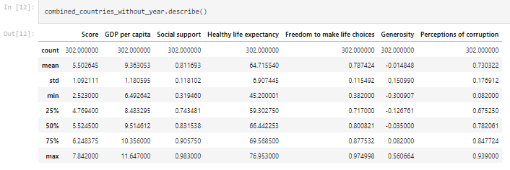

Describe function is showing us our data statistical values as mean, median standard deviation and Quartiles.

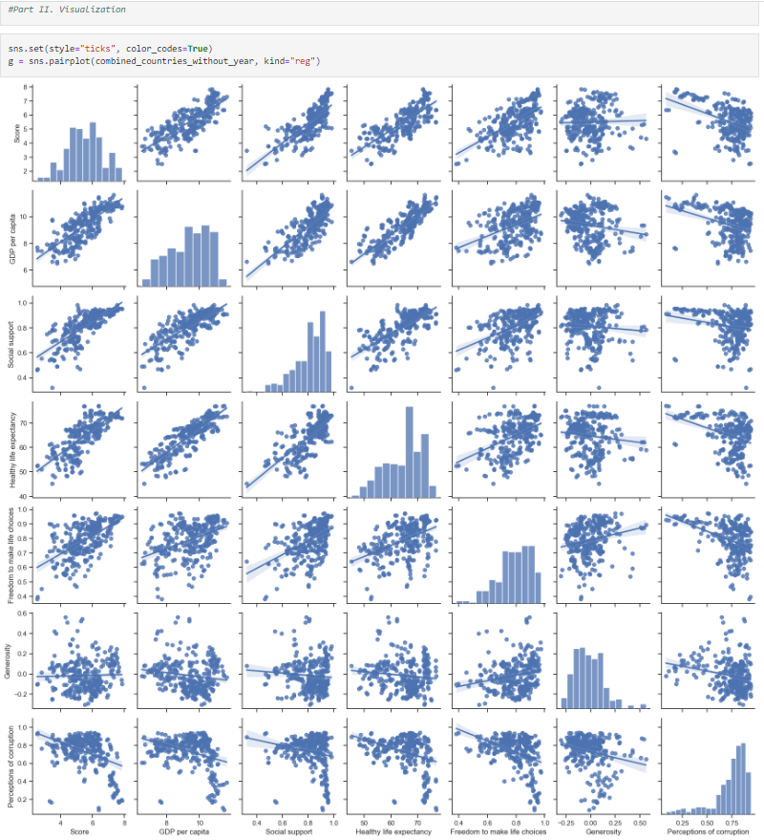

Scatterplots show possible associations or relationships between two variables. We wanted to see each variable positive and negative relationships; uphill lines are showing positive, downhill lines are negative relationships. In above plots are showing that we have weaker, stronger relationships. To quantify the strength of a linear (straight) relationship, we will use a correlation analysis.



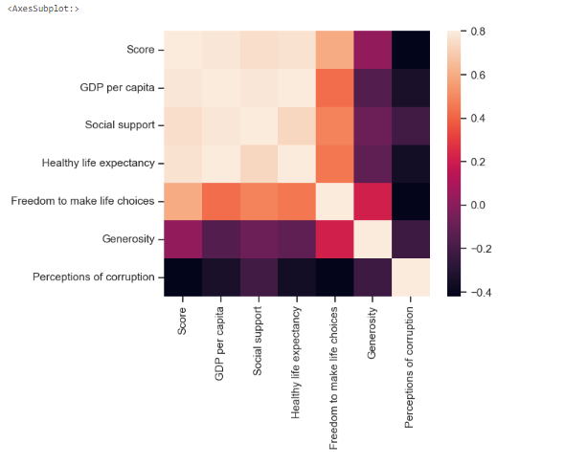

GDP per capita, Perceptions of Corruption, Freedom to make life choices and Healthy Life Expectancy are very highly correlated, in other words when GDP increases Happiness is increasing relatively. GDP is the main factor which is affecting others as Family, Perception of Corruption, Life Expectations and Freedom.

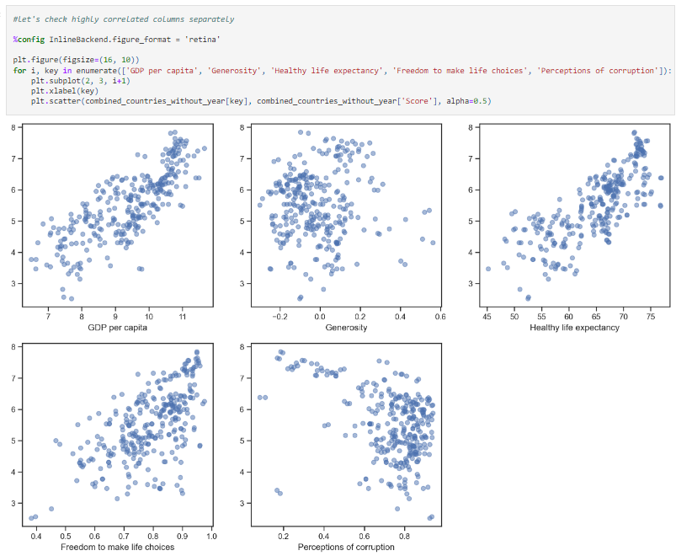

**GDP and Happiness:** It is very common to use a country’s GDP or GDP per capita to evaluate a country’s development and productivity, as well as the well-beings of people. However, over-emphasizing on the ranking of GDP could also be misleading. In particular, it is important to examine people’s happiness index instead of using GDP as a proxy for well-being.

**Healthy Life Expectancy:** When people believe that they will have longer and healthier life, they feel more happier as they do not have to think about diseases and other factors that will shorten their life.

**Freedom to make life choices:** Freedom is positively related to happiness among rich nations, but not among poor nations. Therefore, we can not see highly correlation between. Apparently, freedom does not pay in poverty. Further, freedom is related to happiness only when 'opportunity' and 'capability' coincide.

**Perceptions of Corruption:** Trust to government is including all governmental activities as protection of human rights, the degree of corruption, the level of social trust in a society. In other words, low levels of corruption, a high degree of social trust brings high levels of happiness and social well-being.

**Global Happiness 2021**

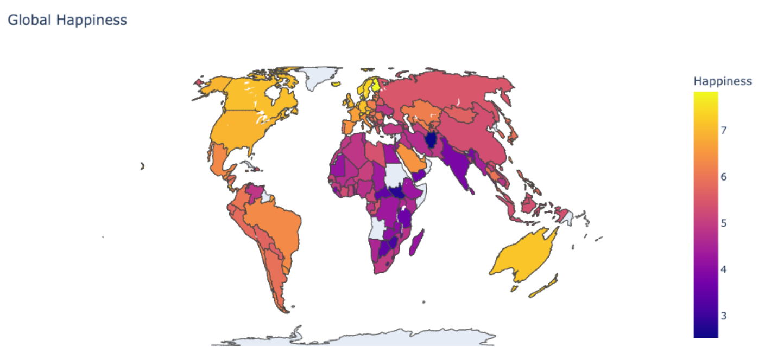

Yellow countries seem to be the most happy countries on above map. Northern Europe, North America, UK, Canada, Australia are on the top. Hong Kong S.A.R. of China is in the average with 5.4936 score. It is expected that African countries are below the average score, we can expect this result as these countries GDP per Capita is very low, Health and Life Expectancies are very low. China is very interesting Country that country is growing economically but happiness of people is very low. Income inequality is another problem to be solved by the Governments. On the other hand, South America has interesting happiness rates, most of them have income inequality, lower GDP per Capita but their happiness is above the average.

As we can see that top 10 happiest countries are same in 2020 and 2021, only small changes in the places as shown in the below table:

|  |  |  |  |
| --- | --- | --- | --- |
| **Country** | **2020 score** | **Country** | **2021 score** |
| Finland | 7.808700085 | Finland | 7.842 |
| Denmark | 7.645599842 | Denmark | 7.62 |
| Switzerland | 7.559899807 | Switzerland | 7.571 |
| Iceland | 7.504499912 | Iceland | 7.554 |
| Norway | 7.487999916 | Netherlands | 7.464 |
| Netherlands | 7.448900223 | Norway | 7.392 |
| Sweden | 7.353499889 | Sweden | 7.363 |
| New Zealand | 7.299600124 | Luxembourg | 7.324 |
| Austria | 7.294199944 | New Zealand | 7.277 |
| Luxembourg | 7.237500191 | Austria | 7.268 |

Luxembourg jumped two spots from 10th to 8th and displaced Austria and New Zealand in 2021. Finland secured the first place in 2021, followed by Denmark, Switzerland, Iceland, Netherlands, Norway, Sweden, Luxembourg, New Zealand and Austria (which tied for tenth place), according to the World Happiness Report, released in March 2021 by the Sustainable Development Solutions Network for the United Nations. Finland has won the title consistently since 2019 to be the Happiest Country in the world.

Let's see Happiness Score on the world map for **2021**

As shown in the data provided, Finland has been consistently ranked as the happiest country in the world in recent years, followed closely by other countries such as Denmark, Switzerland, Iceland and Netherland. These countries are known for their strong social safety nets, high levels of trust and social cohesion, and a focus on work-life balance. Happiest Countries are same but in a different row, Northern Europe is always on top.

As shown in the data provided the last 5 countries as per Ranking, lowest Happiness countries are Afghanistan, Tanzania and Central African Republic (Zimbabwe, Rwanda and Botswana) from 155 countries. Unhappy countries are also from same regions, African Countries are always in the bottom levels.

|  |  |  |  |
| --- | --- | --- | --- |
| **Country** | **2020 score** | **Country** | **2021 score** |
| India | 3.573299885 | Burundi | 3.775 |
| Malawi | 3.538000107 | Yemen | 3.658 |
| Yemen | 3.527400017 | Tanzania | 3.623 |
| Botswana | 3.478899956 | Haiti | 3.615 |
| Tanzania | 3.476200104 | Malawi | 3.6 |
| Central African Republic | 3.475899935 | Lesotho | 3.512 |
| Rwanda | 3.312299967 | Botswana | 3.467 |
| Zimbabwe | 3.299200058 | Rwanda | 3.415 |
| South Sudan | 2.816600084 | Zimbabwe | 3.145 |
| Afghanistan | 2.566900015 | Afghanistan | 2.523 |

It is main problem of all over the world, Africa resources are very limited, climate and environment are not allowing them to improve their life standards. On the other hand, there are wars in some regions like Syria. People had to move from their countries, most of them are trying to survive in other countries refugee camps. This is another big problem for the world, not only Syria but also other countries as Iraq and Afghanistan. etc..

**Questions that we found interesting and what motivated us to answer**

**Countries saw the biggest decrease and increase in happiness between 2020 & 2021**

|  |  |  |  |  |  |  |
| --- | --- | --- | --- | --- | --- | --- |
| **Country or Region** | **Score** | **Year** | **Country or Region** | **Score** | **Year** | **Difference** |
| Malta | 6.7728 | 2020 | Malta | 4.227 | 2021 | -2.545799969 |
| Nepal | 5.1372 | 2020 | Nepal | 7.464 | 2021 | 2.326800121 |

**What factors contributed to the changes in happiness level in Nepal & Malta between 2020 & 2021**

The COVID-19 pandemic has had a significant impact on the happiness levels of people all over the world, and Nepal is no exception. While the overall happiness levels in Nepal may have decreased in 2020, there could be several factors that contributed to changes in happiness levels between 2020 and 2021.

Here are a few possible factors that could have played a role:

Improved access to healthcare, Economic stability, Community support and mental health awareness are the key factors that helped Nepal to contribute into increased happiness level in 2021. The COVID-19 pandemic has had a significant impact on the economy of Nepal, with many people losing their jobs and facing financial hardship in 2020. However, with the gradual lifting of lockdowns and the resumption of economic activities, people may have regained some stability in their financial situations, leading to an increase in happiness level as compared to 2020.

Similarly, there were several factors that contributed to the decrease in happiness levels in Malta in 2021. Despite their best efforts in 2020 to counter Pandemic there was Economic instability, Mental health concerns, and political instability in recent years which may have contributed to a decrease in happiness level.

**Happiest countries in the world for 2020 and 2021**

|  |  |  |  |
| --- | --- | --- | --- |
| **Country** | **2020 score** | **Country** | **2021 score** |
| Finland | 7.808700085 | Finland | 7.842 |
| Denmark | 7.645599842 | Denmark | 7.62 |
| Switzerland | 7.559899807 | Switzerland | 7.571 |
| Iceland | 7.504499912 | Iceland | 7.554 |
| Norway | 7.487999916 | Netherlands | 7.464 |
| Netherlands | 7.448900223 | Norway | 7.392 |
| Sweden | 7.353499889 | Sweden | 7.363 |
| New Zealand | 7.299600124 | Luxembourg | 7.324 |
| Austria | 7.294199944 | New Zealand | 7.277 |
| Luxembourg | 7.237500191 | Austria | 7.268 |

**Unhappiest countries in the world for 2020 and 2021**

|  |  |  |  |
| --- | --- | --- | --- |
| **Country** | **2020 score** | **Country** | **2021 score** |
| India | 3.573299885 | Burundi | 3.775 |
| Malawi | 3.538000107 | Yemen | 3.658 |
| Yemen | 3.527400017 | Tanzania | 3.623 |
| Botswana | 3.478899956 | Haiti | 3.615 |
| Tanzania | 3.476200104 | Malawi | 3.6 |
| Central African Republic | 3.475899935 | Lesotho | 3.512 |
| Rwanda | 3.312299967 | Botswana | 3.467 |
| Zimbabwe | 3.299200058 | Rwanda | 3.415 |
| South Sudan | 2.816600084 | Zimbabwe | 3.145 |
| Afghanistan | 2.566900015 | Afghanistan | 2.523 |

## Conclusion and Analysis summary:

Above analysis are showing that there is no single factor which can explain the happiness of people. Factors such as GDP, family, income inequality, the degree of peace and corruption have important role on happiness. This suggests that when we analyze the happiness, we should consider all factors together.

We know very well that money does not buy happiness by itself but it provides the other factors to be happier as healthier life, trustable government, freedom to make life choices and freedom from corruption, income inequality and levels of peace. GDP is like a catalyzer which is affecting most of the factors.

Happiness isn't just about money, although it's part of it.

"As demonstrated by many countries, this report gives evidence that happiness is a result of creating strong social foundations. It's time to build social trust and healthy lives, not guns or walls. Let's hold our leaders to this fact."

Future is exciting for developed countries as they are working in new technologies, Artificial Intelligence, Electrical Cars, Internet of Things and most of them are ready for climate changes in next decades. Developed countries are investing for clean energy, agricultural sciences and cleaning the air from pollutants. They will surely be the best survived countries against climate changes. We can easily conclude that developed countries will keep their happiness and life standards in future.

On the other hand, poor and unhappy countries will be worsened day after day as they have limited resources, high and not educated population and wars, their future is very dark. Climate change will show the effects very briskly in near future, this will be faster than expected. Afterwards, world will have 2 type of countries, very low standard countries and very high. There will not be middle level country. If this will continue in this way, developed countries will be affected indirectly. We will see more refugees around the developed countries, more wars for the limited sources as oil, clean water and food. Population is increasing uncontrollably, especially in Far East Countries as India, China and Indonesia. Air pollution is another big problem of the world and these crowded countries have the most polluted air, they are over the limits.

To sum up, we can not draw an optimistic table at the end with all these results and conditions. Developed countries will keep their status and they will be happier than the rest of the world. Unhappy countries score will not increase with these circumstances, even their score will decrease every year. Happiness has several factors; GDP is the powerful factor but not the only one. I wish we could have a better world in future but we are afraid this will not happen.

**References:**

The data for the World Happiness Report is typically collected by the Gallup World Poll, which is a large-scale survey conducted annually in over 150 countries. The report is published by the Sustainable Development Solutions Network, which is a global initiative launched by the United Nations in 2012.

The data for the report is publicly available on the World Happiness Report website, which includes detailed country-level and regional-level data for both 2020 and 2021. The website provides access to downloadable datasets, country profiles, and other resources.

Researchers and analysts can also access the raw data from the Gallup World Poll through the Gallup Analytics platform, which allows users to create custom reports and analyses using the survey data. The Gallup Analytics platform requires a subscription, but it provides access to a wide range of data and insights on global social, economic, and political trends.

<http://www.dummies.com/education/math/statistics/how-to-interpret-a-scatterplot/>

<http://support.minitab.com/en-us/minitab-express/1/help-and-how-to/graphs/scatterplot/interpret-the-results/key-results/>

<https://www.miuc.org/higher-gdp-per-capita-more-happiness/>

<http://www.independent.co.uk/life-style/health-and-families/health-news/the-secret-of-happiness-family-friends-and-your-environment-2053053.html>

<http://www.actionforhappiness.org/10-keys-to-happier-living/family-and-friends/details>

<https://personal.eur.nl/veenhoven/Pub2000s/2000a-full.pdf>

<http://edition.cnn.com/travel/article/worlds-happiest-countries-united-nations-2017/index.html>